Pengolahan Citra

**3. Enhancement : brigthness kuantisasi**

**Dosen Pengampu**

Hero Yudo Martono ST, MT



**Disusun Oleh :**

Nama : M. Faza Nur Husain

Nrp : 3121550004

**D3 PJJ AK TEKNIK INFORMATIKA**

**POLITEKNIK ELEKTRONIKA NEGERI SURABAYA**

**TAHUN AKADEMIK 2021/2022**

**Source Code :**

from sqlite3 import Row

from cv2 import imshow

import numpy as np

import cv2

from matplotlib import pyplot as plt

import matplotlib.image as mpimg

import time

from array import *

# Main Function

def flip_image():

    img = mpimg.imread('img/kuda.jpg')

    horizontal_img = cv2.flip(img, 1)

    vertical_img = cv2.flip(img, 0)

    both_img = cv2.flip(img, -1)

    plt.subplot(2, 2, 1), plt.imshow(img)

    plt.title('Original'), plt.xticks([]), plt.yticks([])

    plt.subplot(2, 2, 2), plt.imshow(horizontal_img)

    plt.title('Flip Horizontal'), plt.xticks([]), plt.yticks([])

    plt.subplot(2, 2, 3), plt.imshow(vertical_img)

    plt.title('Flip Vertikal'), plt.xticks([]), plt.yticks([])

    plt.subplot(2, 2, 4), plt.imshow(both_img)

    plt.title('Flip both'), plt.xticks([]), plt.yticks([])

    plt.show()

    return

def enchancement():

    img = mpimg.imread('img/kuda.jpg')

    row, col, n = img.shape

    img1 = np.zeros((row, col, 3), np.uint8)

    img2 = np.zeros((row, col, 3), np.uint8)

    img3 = np.zeros((row, col, 3), np.uint8)

    img4 = np.zeros((row, col, 3), np.uint8)

    img5 = np.zeros((row, col, 3), np.uint8)

    th = 50

    for y in range(0, col-1):

        for x in range(0, row-1):

            R, G, B = img[x, y]

            if (R+th) > 255:

                R = 255

            else:

                R = R+th

            if (G+th) > 255:

                G = 255

            else:

                G = G+th

            if (R+th) > 255:

                R = 255

            else:

                R = R+th

            img1[x, y] = [R, G, B]

    th = 4

    for y in range(0, col-1):

        for x in range(0, row-1):

            R, G, B = img[x, y]

            if (R*th) > 255:

                R = 255

            else:

                R = R*th

            if (G*th) > 255:

                G = 255

            else:

                G = G*th

            if (R*th) > 255:

                R = 255

            else:

                R = R*th

            img2[x, y] = [R, G, B]

    xmax = 0

    xmin = 300

    for y in range(0, col-1):

        for x in range(0, row-1):

            R, G, B = img[x, y]

            gray = int((R+G+B)/3)

            if(gray > xmax):

                xmax = gray

            if(gray < xmin):

                xmin = gray

    d = xmax-xmin

    for y in range(0, col-1):

        for x in range(0, row-1):

            R, G, B = img[x, y]

            gray = int((R+G+B)/3)

            gray = int((255/d)*gray-xmin)

            img3[x, y] = [gray, gray, gray]

    print("xmax=", xmax)

    print("xmin=", xmin)

    titles = ['Original Image', 'BRIGHTNESS', 'CONTRAST', 'AUTO SCALE']

    images = [img, img1, img2, img3]

    for i in range(4):

        plt.subplot(2, 2, i+1), plt.imshow(images[i], 'gray', vmin=0, vmax=255)

        plt.title(titles[i])

        plt.xticks([]), plt.yticks([])

    plt.show()

    return

# ======Main Program=======

# flip_image()

# enchancement()

**Output Code :**

**flip_image()**

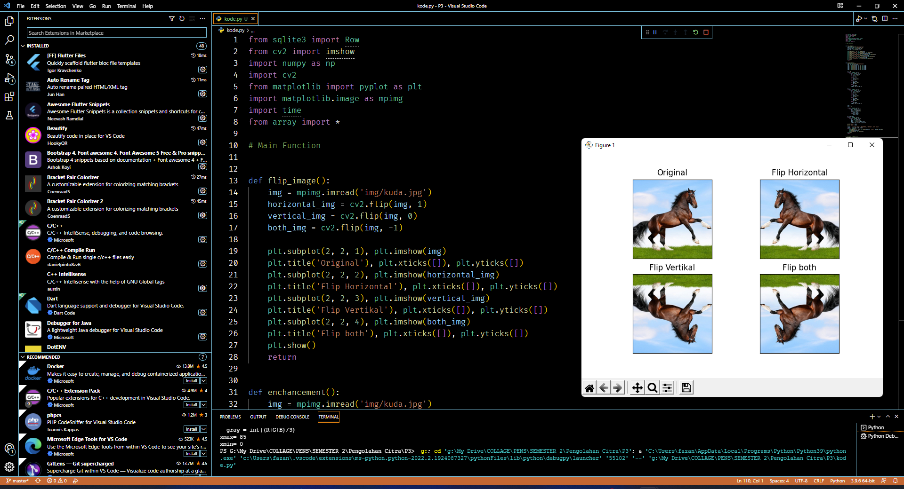

**enchancement()**

